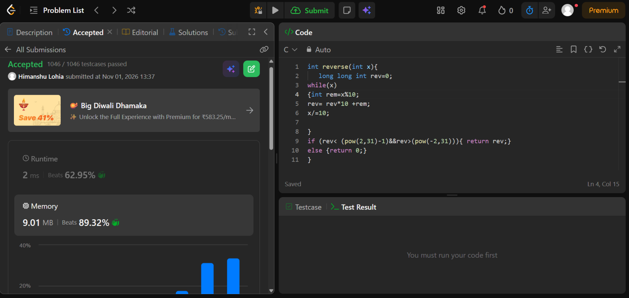
https://leetcode.com/problems/reverse-integer/

int reverse(int x){
long long int rev=0;
while(x)
{int rem=x%10;
rev= rev*10 +rem;
x/=10;

}
if (rev< (pow(2,31)-1)&&rev>(pow(-2,31))){ return rev;}
else {return 0;}
}

